Deliverable 1: High-Level Design (HLD)
Project: ShopEase RAG-Based Customer Support Assistant
Engineer: Ruchitha
Date: April 2026
1. System Overview
Problem Definition
Traditional customer support bots often hallucinate or provide generic answers. Businesses need a system that stays grounded in specific company data (PDFs) but also knows its own limits—escalating to a human when it lacks confidence or encounters sensitive issues (like refunds).
Scope
A Python-based RAG system using LangGraph to manage state, ChromaDB for vector storage, and Llama 3.3 for intelligent response generation.
2. Architecture Diagram
The system follows a modular pipeline where data moves from raw unstructured text to structured AI responses.
- Ingestion Path: PDF → Recursive Character Splitting → HuggingFace Embeddings → ChromaDB.
- Query Path: User Query → Vector Search → Contextual Prompt → Graph Routing → Output.

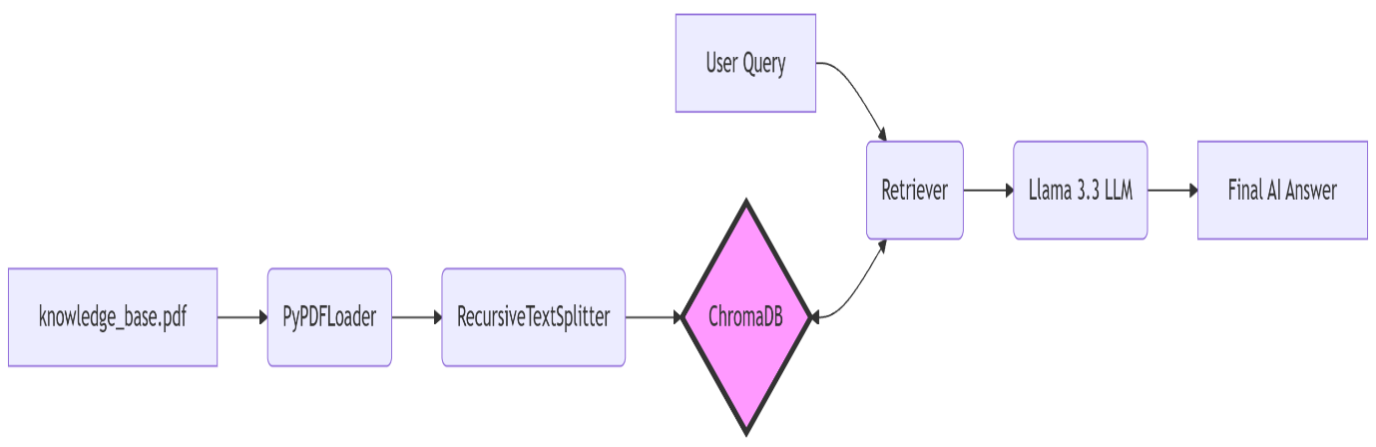

3. Component Description
Component | Technology | Description
Document Loader | PyPDFLoader | Reads the knowledge_base.pdf file.
Chunking Strategy | RecursiveCharacterTextSplitter | Breaks text into 1000-character segments with a 100-character overlap to preserve context.
Embedding Model | all-MiniLM-L6-v2 | Converts text chunks into 384-dimensional vectors.
Vector Store | ChromaDB | Stores and performs similarity searches on embedded chunks.
LLM | Llama-3.3-70b-versatile | The "brain" that generates friendly support responses via the Groq API.
Graph Engine | LangGraph | Manages the "State" of the conversation and coordinates nodes.
Routing Layer | Conditional Edges | A logic gate that decides between "Generate" or "Escalate".

4. Data Flow
- Ingestion Phase: The ingest.py script processes the PDF and populates the chroma_db folder.
- Retrieval Node: The system searches the DB. It calculates "Confidence" based on how many relevant chunks it finds.
- Router: Checks for "Escalation Keywords" (refund, manager) and verifies the Confidence score.
- Generation Node: If safe, the LLM combines the user's question with the retrieved PDF text to answer.
- Escalation Node: If unsafe or unsure, the system bypasses the LLM and triggers a Human-in-the-Loop notification.

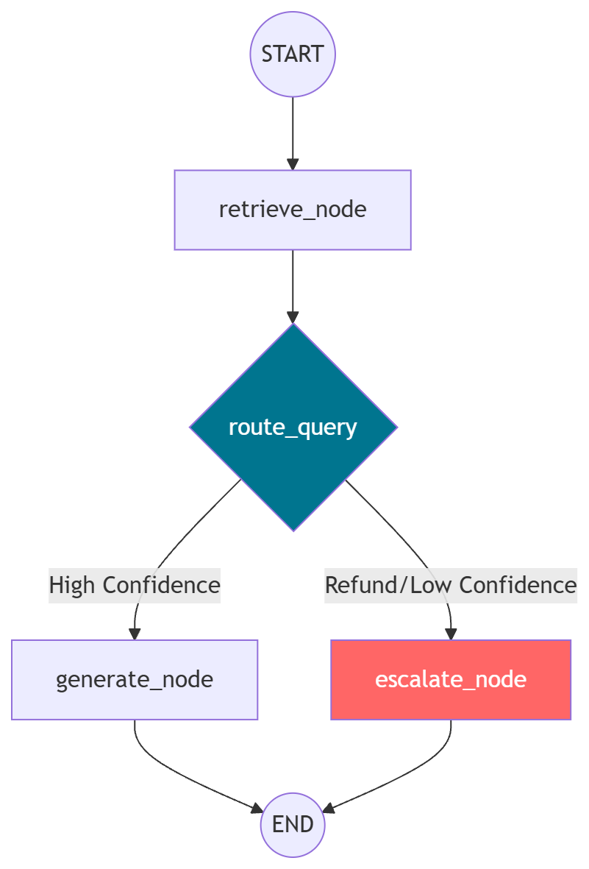

5. Technology Choices
- ChromaDB: Lightweight, persistent, and integrates perfectly with LangChain for local development.
- LangGraph: Chosen over standard linear chains because customer support requires branching logic (routing) and cycles, which standard RAG cannot handle.
- Groq (Llama 3.3): Provides ultra-fast inference speed, making the support bot feel "real-time."
6. Scalability Considerations
- Document Growth: As the PDF grows, we can implement Parent Document Retrieval to keep the context concise.
- Concurrency: The use of app.stream() allows the system to handle multiple tokens at once, reducing perceived latency.
- HITL Integration: In a production scale, the "Escalation Node" would send a webhook to a Slack channel or a Zendesk ticket.

